Franklin Nuth

CSC432 – A

Lab 1 Report

17 January 2019

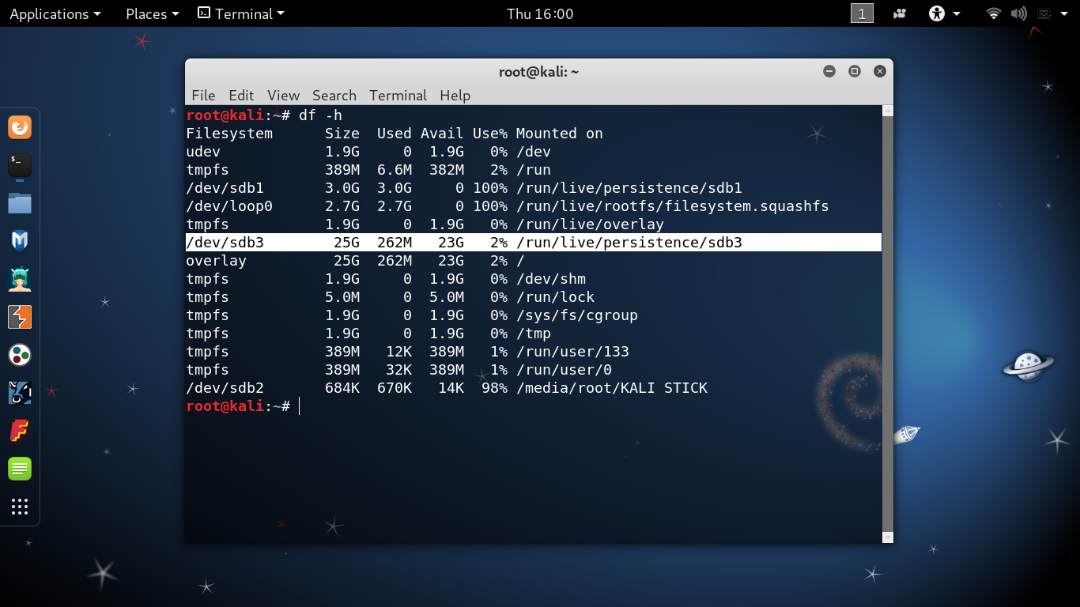*(Proof that my Kali Linus USB is persistent. I turned the unallocated space on my USB into a ext4 partition named persistence, mounted it, created a configuration file, and unmounted it.)*

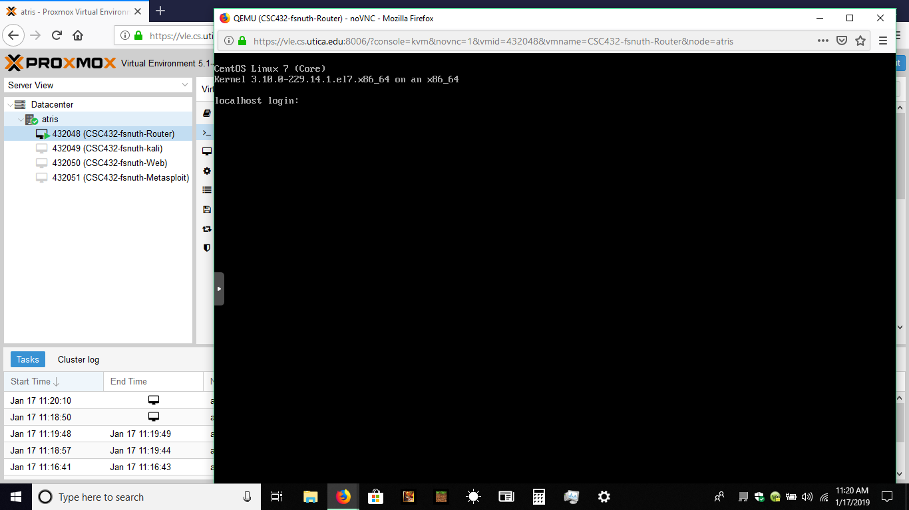*(My access to the VNC session on ProxMox.)*